

SRI LANKA INSTITUTE OF INFORMATION TECHNOLOGY

[**Enterprise Standards and Best Practices for IT Infrastructure**](http://courseweb.sliit.lk/course/view.php?id=137)

**4th Year 2nd Semester 2014**

Name:D.S.S.Dharmachandra

SLIIT ID:IT13136734

Group Number:

Practical Session: WD

Practical Number : Lab 01

Date of Submission: 30/07/2016

Date of Evaluation : _____________________

Evaluators Signature : ____________________

Introduction

 An instance is a virtual server in the AWS cloud. With Amazon EC2, can set up and configure the operating system and applications that run on an instance.

The instance is an Amazon EBS-backed instance (meaning that the root volume is an EBS volume). You can either specify the Availability Zone in which your instance runs, or let Amazon EC2 select an Availability Zone for you. When you launch your instance, you secure it by specifying a key pair and security group. When you connect to your instance, you must specify the private key of the key pair that you specified when launching your instance.

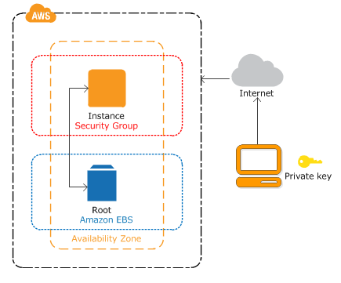

**Practical 1**

**Create a windows instance**

* **Launch an instance**

Open the Amazon EC2 console at <https://console.aws.amazon.com/ec2/> and

From the console dashboard, choose **Launch Instance**.

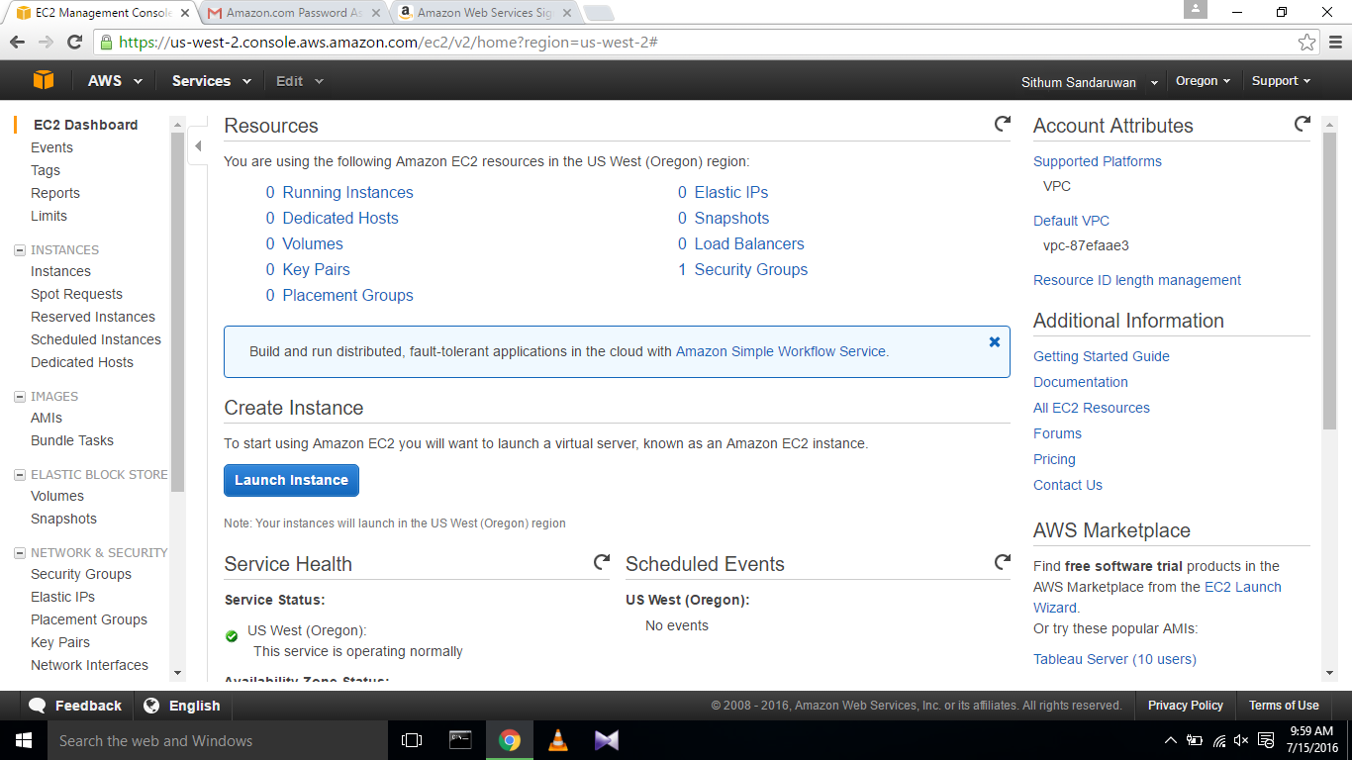

The **Choose an Amazon Machine Image (AMI)** page displays a list of basic configurations, called Amazon Machine Images (AMIs) that serve as templates for your instance. Select the AMI for Microsoft Windows Server 2012 R2 Base or Microsoft Windows Server 2008 R2 Base. 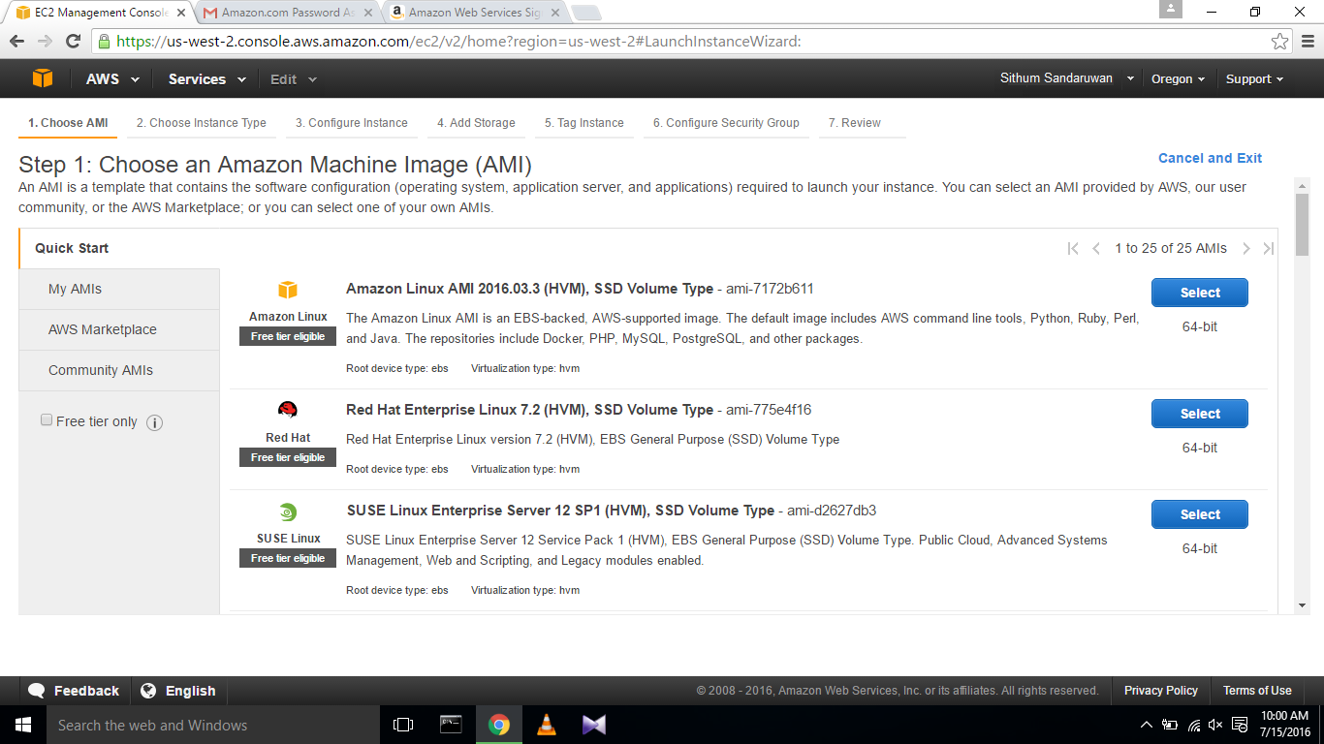

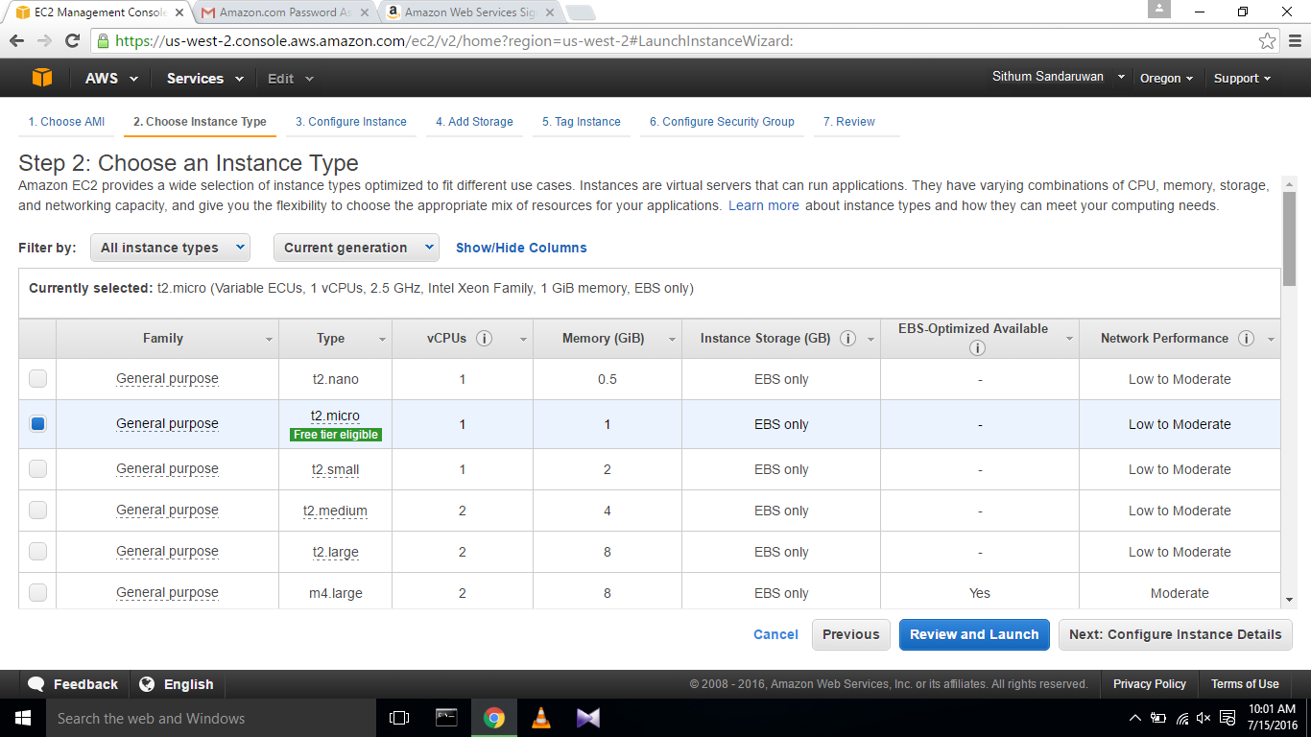

Choose **Review and Launch** to let the wizard complete the other configuration settings.

On the **Review Instance Launch** page, choose **Launch**.

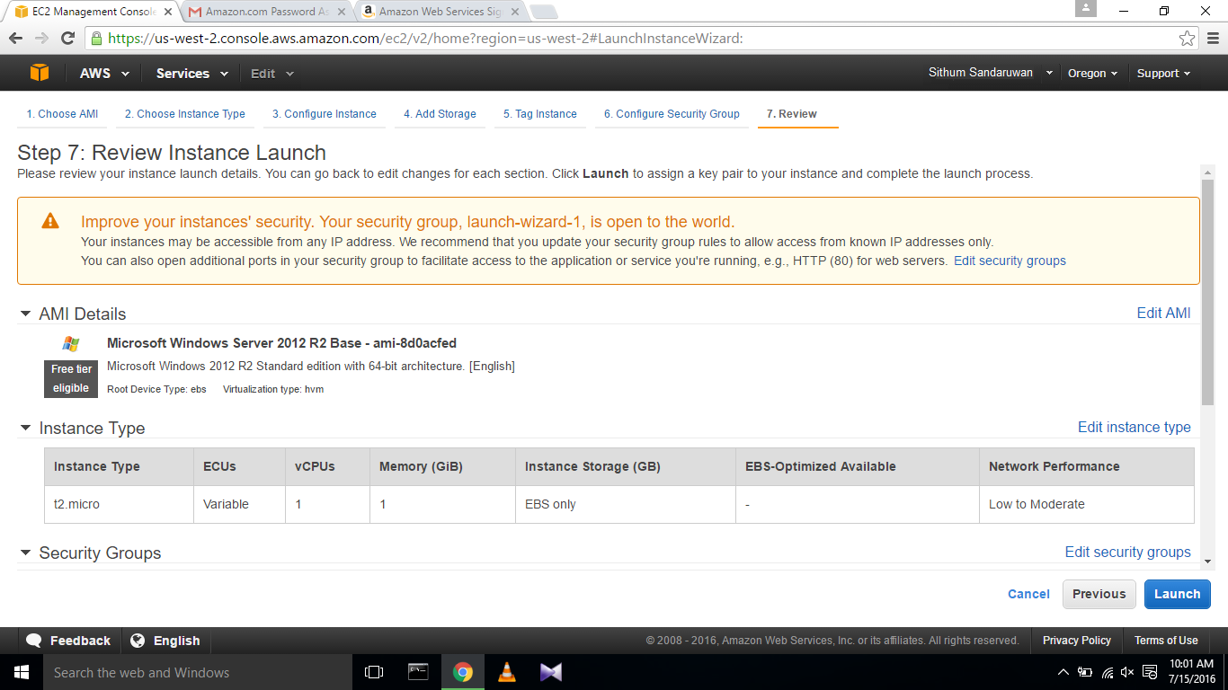

When prompted for a key pair, select **Create a new key pair**, then select the key pair that you created when getting set up. When you are ready, select the acknowledgement check box, and then choose **Launch Instances**.

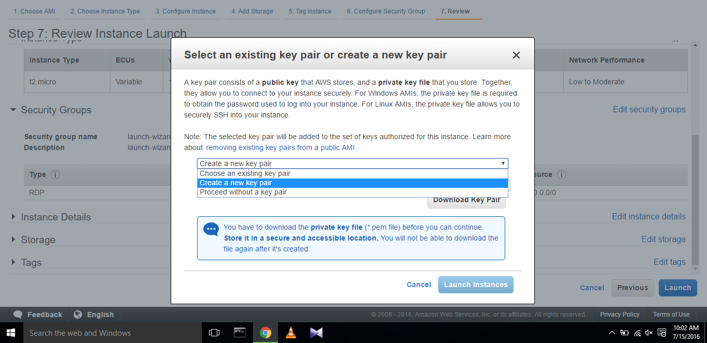

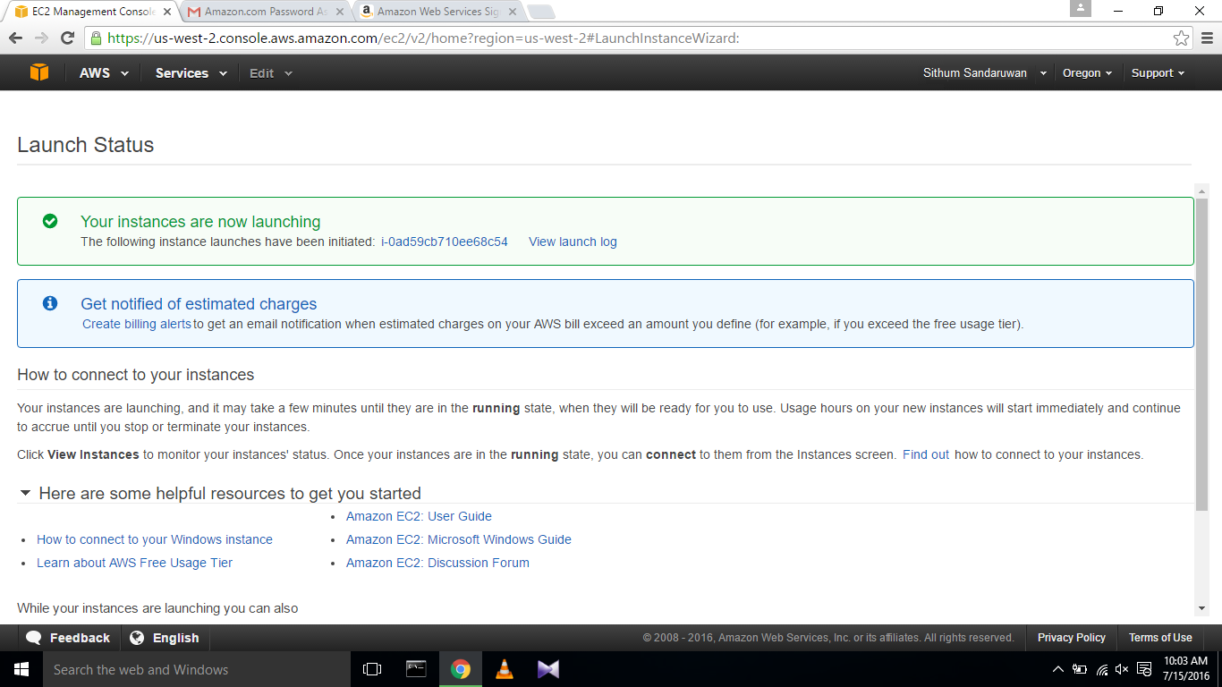

On the **Instances** screen, you can view the status of the launch. It takes a short time for an instance to launch. When you launch an instance, its initial state is pending. After the instance starts, its state changes to running and it receives a public DNS name.

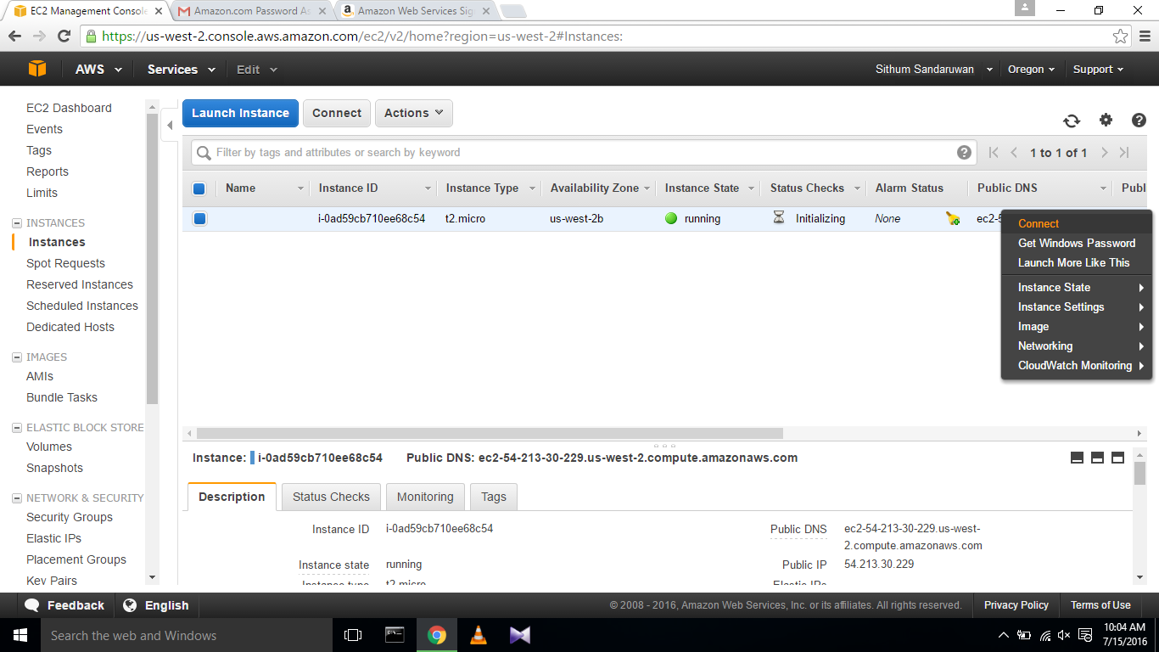

* **Connect the instance.**

In the **Connect to Your Instance** dialog box, choose **Get Password**

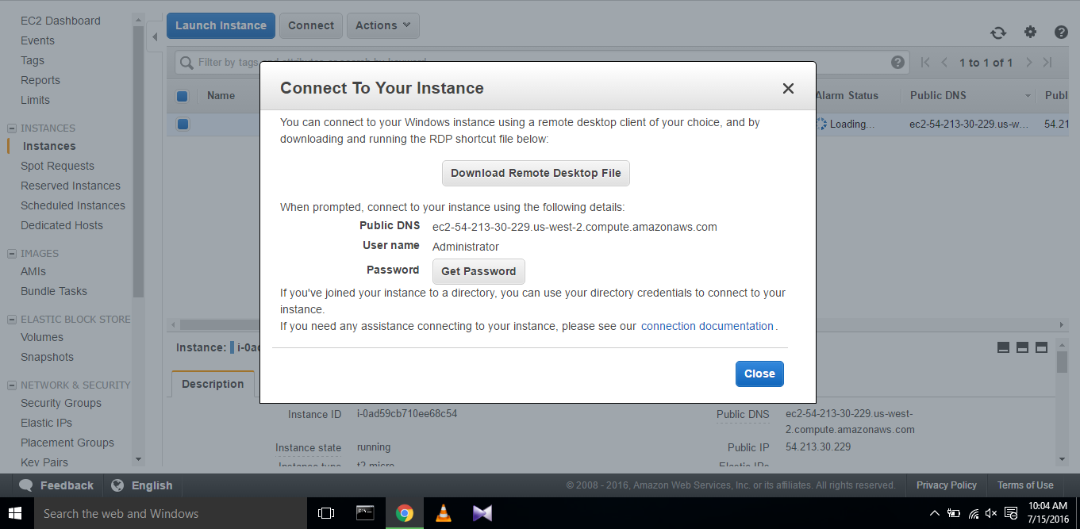

Choose **Browse** and navigate to the private key file you created when you launched the instance. Select the file and choose **Open** to copy the entire contents of the file into contents box.

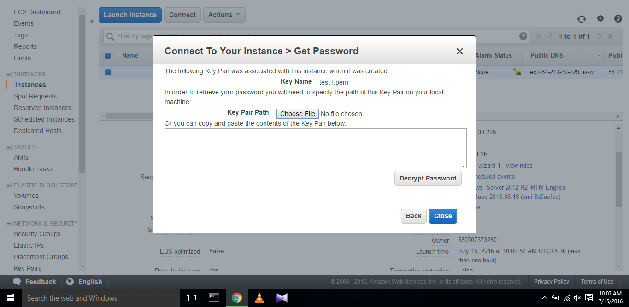

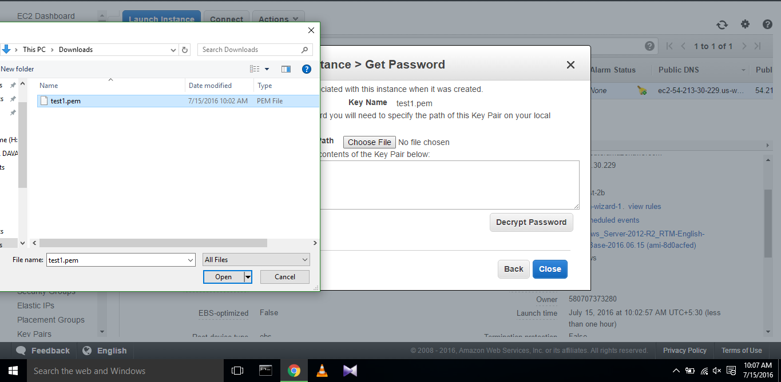

Choose **Decrypt Password**. The console displays the default administrator password for the instance in the **Connect to Your Instance** dialog box, replacing the link to **Get Password** shown previously with the actual password.

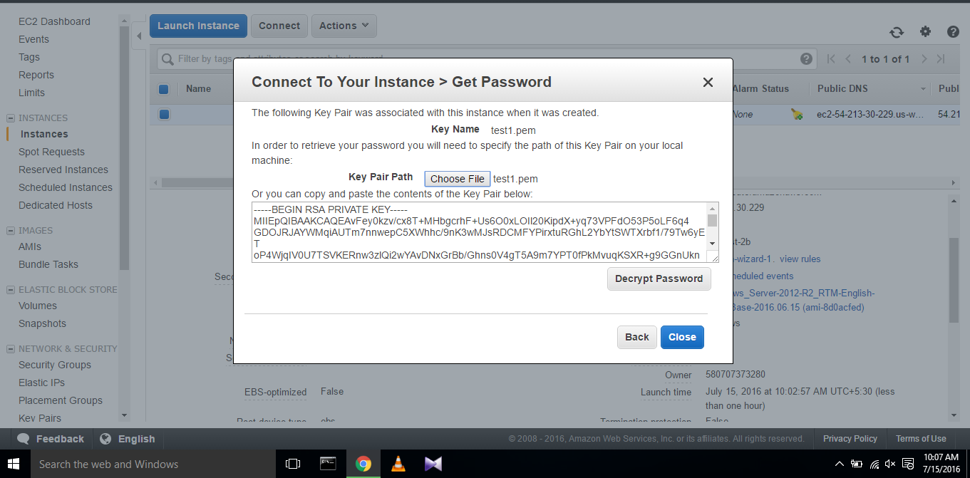

 When you have finished, you can choose **Close** to dismiss the **Connect to Your Instance** dialog box.

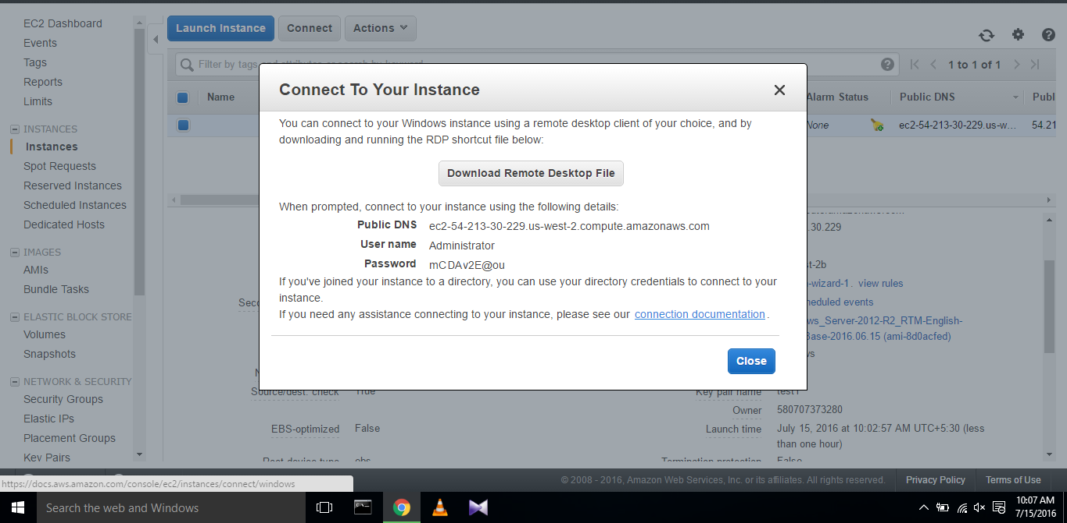

Open **Remote Desktop Connection**. And continue as following.

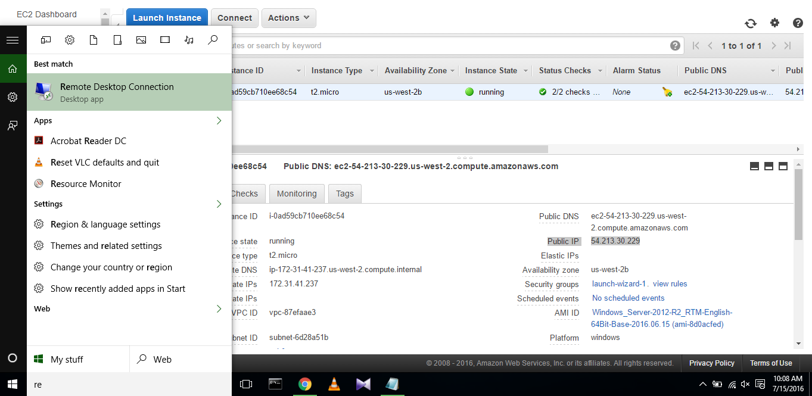

Enter the previously generated public ip address and user name in remote desktop connection dialog box and select connect.

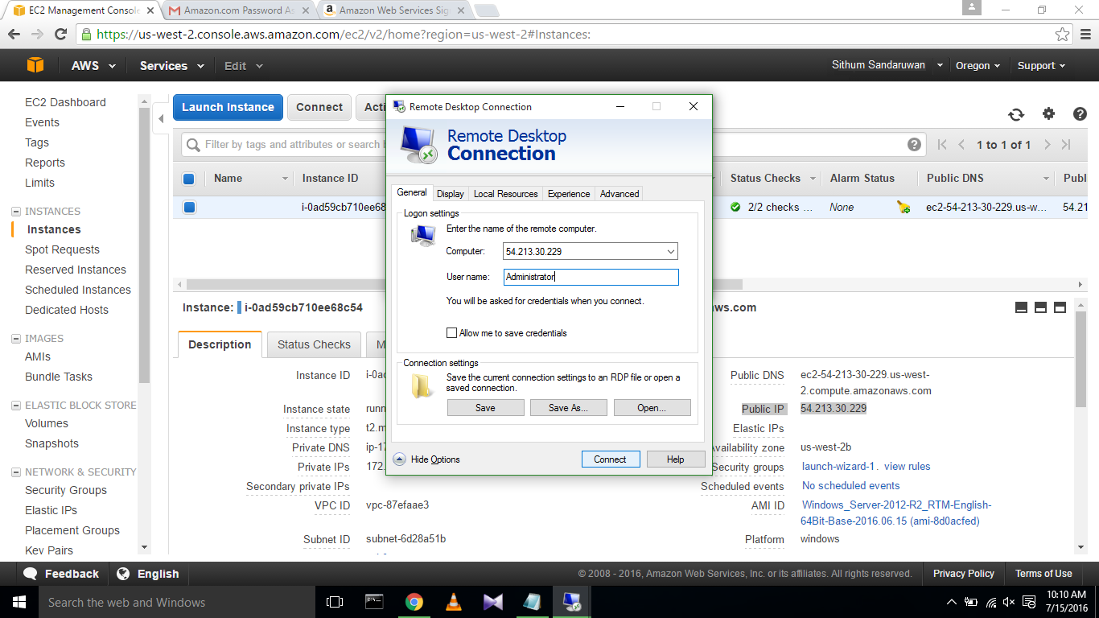

Next prompt dialog box enter the password under administrator and click ok.

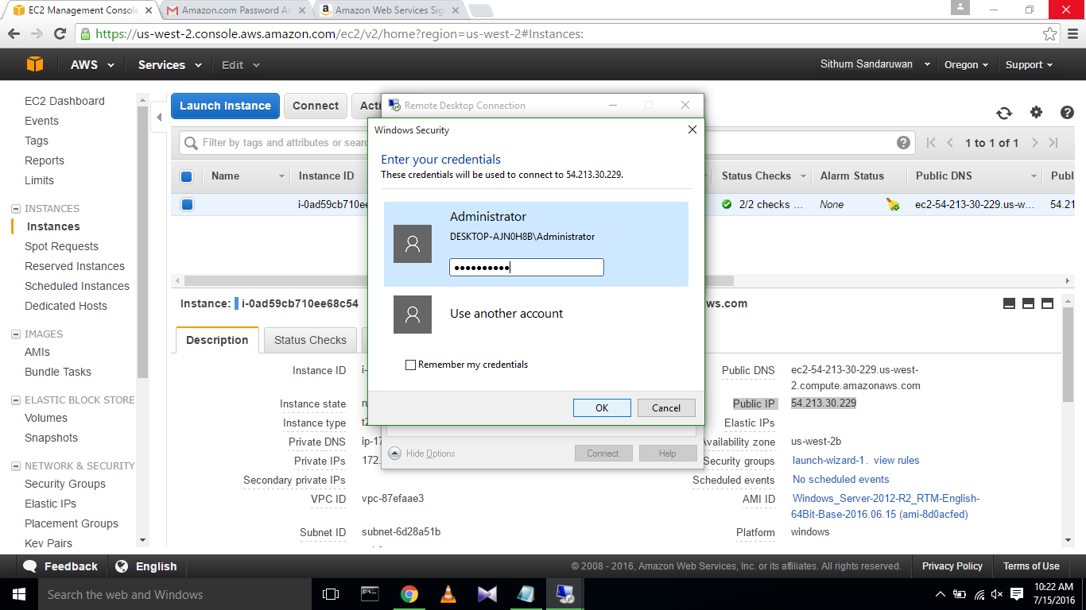

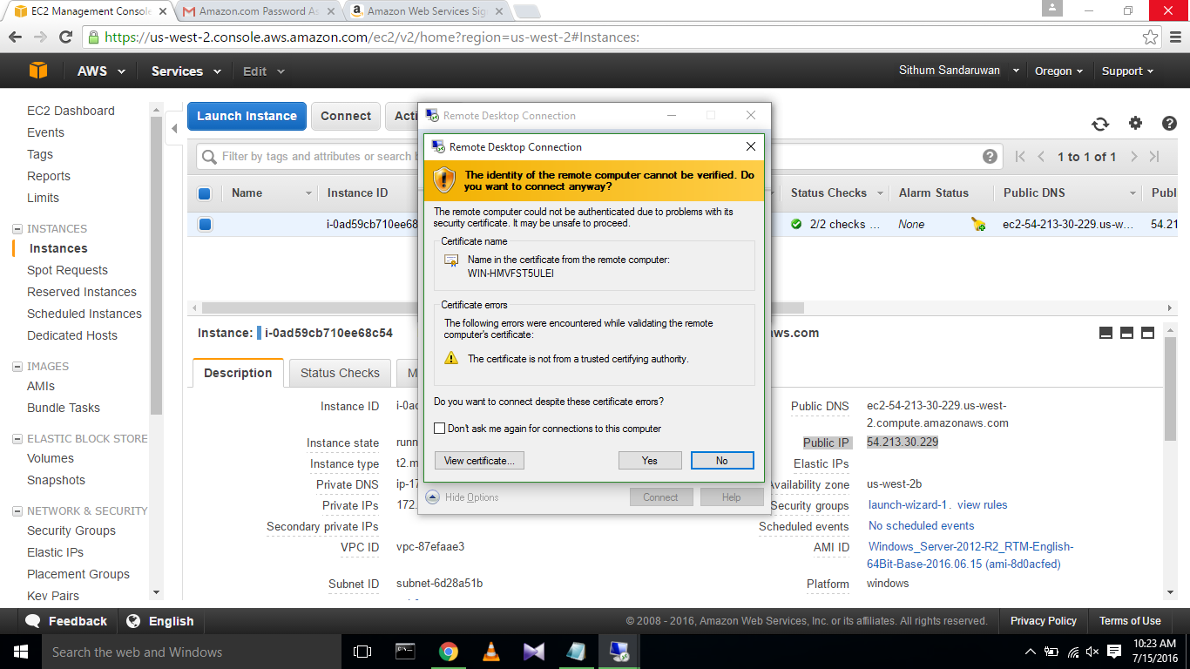

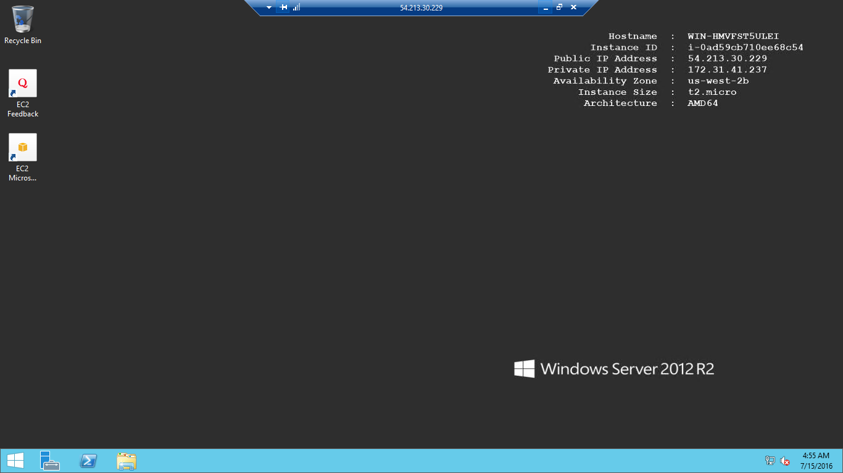

* **References:**

<http://docs.aws.amazon.com/AWSEC2/latest/WindowsGuide/EC2_GetStarted.html>